1. Feature Importance Analysis
Feature importance analysis was conducted using both Logistic Regression and Random Forest models to identify the key variables influencing the prediction of Ten-Year Coronary Heart Disease (TenYearCHD). Logistic Regression provides coefficients that indicate both the magnitude and direction of influence of each feature, whereas Random Forest evaluates feature importance based on its contribution to reducing classification error.
The Logistic Regression model indicates that age (0.7285) is the most significant positive predictor, followed by cigarettes per day (0.5562), diastolic blood pressure (0.3123), and systolic blood pressure (0.2228). These results suggest that increasing age, smoking intensity, and blood pressure levels significantly increase the likelihood of coronary risk. In contrast, variables such as current smoking status, prevalent stroke, and hypertension history show negative coefficients, which may indicate interactions within the dataset or multicollinearity effects.
The Random Forest model confirms the dominance of clinical variables, with age (0.1870) emerging as the most important feature, followed by systolic blood pressure (0.1256), diastolic blood pressure (0.1128), and total cholesterol (0.1086). Additional contributors include heart rate (0.1076), BMI (0.1002), and glucose levels (0.0991), highlighting the importance of physiological health indicators in predicting coronary risk.
Across both models, a consistent pattern emerges, indicating that cardiovascular risk is primarily driven by age, blood pressure, cholesterol, and lifestyle factors such as smoking.
Logistic Regression (Top Features)
Feature | Coefficient Value
Age | 0.7285
CigsPerDay | 0.5562
DiaBP | 0.3123
SysBP | 0.2228
Total Chol | 0.0987

Random Forest (Top Features)
Feature | Importance Score
Age | 0.1870
SysBP | 0.1256
DiaBP | 0.1128
Total Chol | 0.1086
Heart Rate | 0.1076

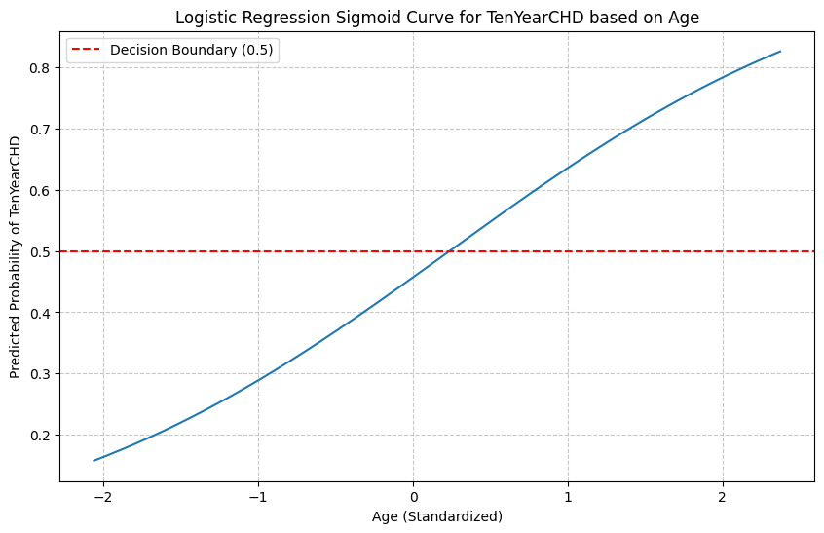
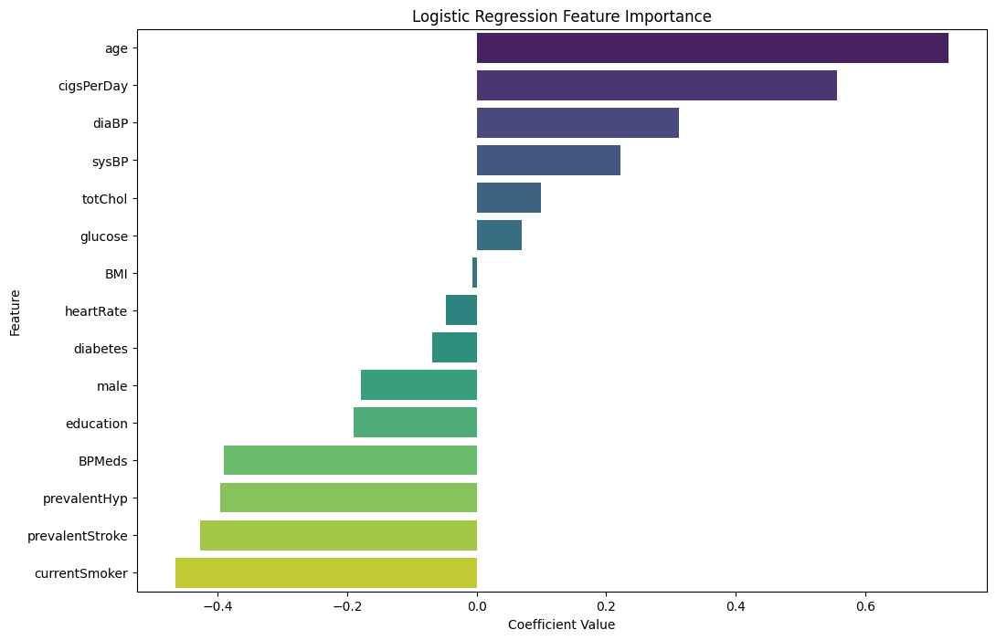
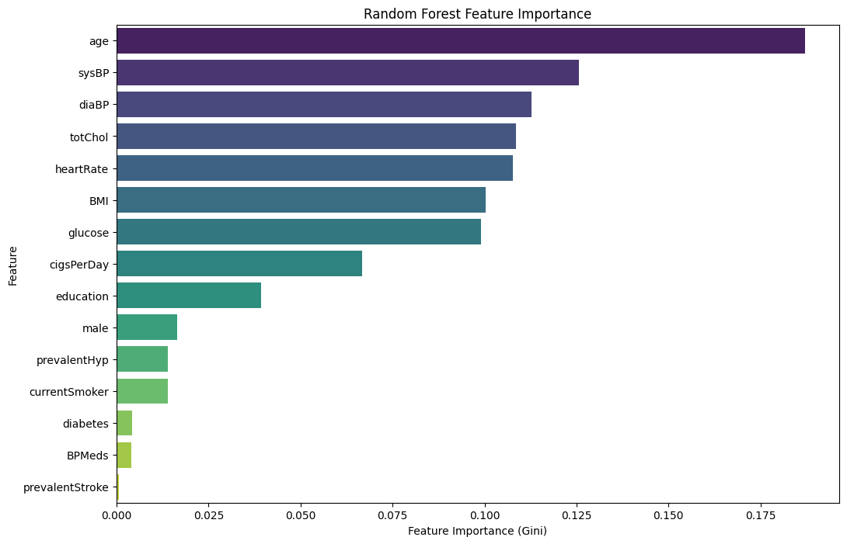

2. Top 5 Risk Factors
Based on combined insights from both models, the top five risk factors identified are:
- Age
- Systolic Blood Pressure (sysBP)
- Diastolic Blood Pressure (diaBP)
- Total Cholesterol (totChol)
- Cigarettes Per Day (cigsPerDay)
These factors exhibit the strongest influence on coronary risk prediction and are clinically aligned with established cardiovascular risk determinants.

3. Risk Scoring Interpretation
The model outputs provide a probabilistic risk score representing the likelihood of a patient developing coronary heart disease within ten years. For example, the predicted risk score for a high-risk individual is 0.9796, indicating a very high probability of disease occurrence, whereas a healthy individual exhibits a significantly lower risk score of 0.0733.
This demonstrates that the model effectively differentiates between high-risk and low-risk individuals based on input features. The sigmoid curve further illustrates that as age increases, the predicted probability of coronary disease rises significantly, reinforcing the importance of age as a dominant risk factor.
The risk scoring mechanism enables intuitive interpretation, allowing healthcare professionals to categorize patients into risk groups and prioritize interventions accordingly.

4. Business and Clinical Insights
The analysis provides several important insights. First, the strong influence of age suggests that preventive care should be increasingly targeted toward older populations. Second, the prominence of blood pressure and cholesterol highlights the need for continuous monitoring and management of cardiovascular health indicators.
Lifestyle-related factors, particularly smoking intensity, also play a significant role, indicating that behavioural interventions can substantially reduce risk levels. The consistency between Logistic Regression and Random Forest results enhances the reliability of these findings, supporting their applicability in real-world scenarios.
Furthermore, the results demonstrate the effectiveness of machine learning models in transforming raw healthcare data into actionable insights, enabling a shift from reactive treatment to proactive risk management.
5. Conclusion
The feature importance analysis conducted using both Logistic Regression and Random Forest models provides a comprehensive understanding of the key determinants of Ten-Year Coronary Heart Disease (TenYearCHD). The results consistently highlight age, blood pressure, cholesterol levels, and smoking behaviour as the most significant predictors of cardiovascular risk, aligning with established medical knowledge.
The integration of machine learning techniques enables a shift from traditional, reactive healthcare approaches to proactive and preventive strategies. By identifying high-risk individuals through data-driven insights, healthcare providers can implement targeted interventions, improve patient outcomes, and optimize resource allocation.
Furthermore, the risk scoring mechanism enhances interpretability, allowing stakeholders to make informed decisions based on probabilistic outcomes. The consistency across models strengthens the reliability of the findings, reinforcing their applicability in real-world healthcare settings.
Overall, this analysis demonstrates the potential of predictive analytics in transforming healthcare decision-making. By leveraging feature importance and risk prediction models, organizations can move towards personalized healthcare solutions, early diagnosis, and efficient disease management, ultimately contributing to improved public health outcomes.

